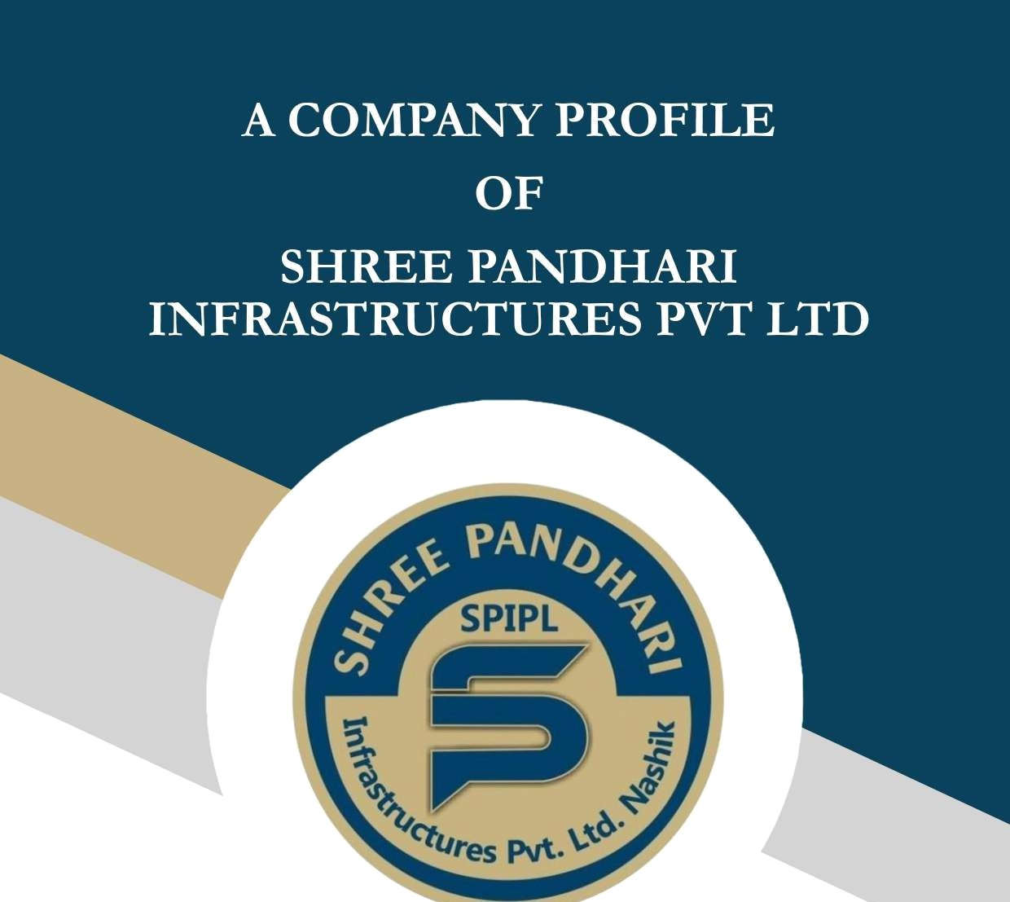
•GOVT. CONTRACTOR
•REAL ESTATE

•LAND DEVELOPERS

•LEADERSHIP IN CONCRETE SOLUTION
•ROAD INFRA


COMPANY PROFILE
We are pleased to introduce SHREE PANDHARI INFRASTRUCTURE PVT LTD, for- merly known as M/s. Borade Builders, as one of the most resourceful, leading, and profes- sionally managed ISO 9001:2014 certified companies engaged in civil construction work.
Our projects include irrigation projects, dams, barrages, canals, aqueducts, lift irrigation, transmission, distribution, substations, highways, bridges, and institutional and residential buildings across Maharashtra. Over the past 15 years, we have established our credentials with reputed civil engineering contractors.

1 VISION
“To be a leader in the construction industry by setting standards in technology, quality, and deliverables while ensuring the growth of employees and creating value.”
SHREE PANDHARI INFRASTRUCTURE PVT LTD is recognized as one of the leading Indian engineering construction companies, having executed several landmark projects across India in diverse sectors, including irrigation, dams, barrages, canals, aqueducts, lift irrigation, transmission, distribution, substations, highways, bridges, and institutional and residential buildings.
Driven by a constant endeavor to upgrade our expertise, we provide state-of-the-art infra- structure solutions to our clients. Our reputation for engineering and construction excel- lence is built on our ability to offer multi-disciplinary, innovative, and cost-effective solu- tions to critical projects. With 25 years of construction experience, a large and motivated workforce, proven procedures, work systems, and unique databases, SHREE PANDHARI INFRASTRUCTURE PVT LTD is committed to delivering quality construction solutions.

1 SETTING STANDARDS:
In line with our vision, SHREE PANDHARI INFRASTRUCTURE PVT LTD has success- fully executed diverse projects with uncompromising quality, total commitment, and dedi- cation, often completing projects ahead of schedule. Over the years, we have reached sever- al milestones, set performance benchmarks, and received numerous awards in recognition of our achievements.

Z QUALITY ASSURANCE: WORLD-CLASS COMPETENCE
SHREE PANDHARI INFRASTRUCTURE PVT LTD is committed to maintaining the highest standards of quality across its services. Our quality assurance policy is evidenced by our ISO 9001:2014 certification by Certification International Ltd. We have worked with experts in various state governments and on internationally funded projects, adopting new technologies and complying with national and international standards and practices.

X QUALITY POLICY:
“To optimize processes through continuous improvement and to execute projects on time and economically, thereby enhancing customef satisfaction.

I OCCUPATIONAL HEALTH, SAFETY & ENVIRONMENT (OHS&E) POLICY:
We are committed to:
- Complying with all applicable OHS&E legislation in all our activities.
- Continually improving our OHS&E performance to control and reduce risks associated with our construction activities.
- Promoting awareness regarding OHS&E obligations among employees and associates to ensure a proactive OHS&E risk management system.
- Providing a safe and healthy working environment.
- Continually improving and sustaining environmental conditions at all our construction sites.

1 HEALTH, SAFETY & ENVIRONMENT:
Employee safety is out top priority. With the objective of achieving a zero-accident rate, SHREE PANDHARI INFRASTRUCTURE PVT LTD emphasizes both construction pro- cess safety and behavior-based safety. We provide the best quality personal protective equip- ment at all project sites, along with periodic safety training programs organized by the HR department. We have implemented stringent safety practices to minimize hazards at project sites, reinforcing safety consciousness and safe work procedures to reduce accidents.
Health and education for employees and their families are also high on our priority list. We offer comprehensive employee well-being amenities at all offices and project sites. Emer- gency medical aid is mandatory at all project sites, and we conduct regular health camps covering all specialties of medicine to ensure a healthy workforce.

ENVIRONMENTAL PROTECTION
Development and growth inherently impact the environment. However, through proactive planning, we work to preserve open spaces and protect environmentally sensitive areas.
SHREE PANDHARI INFRASTRUCTURE PVT LTD places top priority on environmen- tal management and protection in all its operations. We strive to educate and adopt environ- mentally friendly methods of project execution at all sites in active collaboration with our clients. Through adequate pre-planning, we have transformed many project sites into serene locales.

IT ADYANTAGB
Our state-of-the-art information technology platform supports all engineering and

construction projects nationwide. This includes a wide range of applications to collect, pro- cess, and share information across all lines of business. This standardization of business processes ensures a common information model supporting various functions of the com- pany. Business process automation enables timely decision-making, compliance with quali- ty, statutory, and regulatory commitments, and fosters teamwork beyond individual func- tions. Our corporate sustainability is strengthened by management-level views into the en- terprise, driven by KPIs and monitored by executive dashboards for timely alerts and proac- tive decision-making.

ENYIRONMENT AND ENERGY MANAGEMENT
Our entire computing capacity is deployed on virtualized servers for their tremendous energy utilization benefits. By reducing the number of physical servers and maximizing CPU usage, we have cut costs, reduced space requirements, and minimized our carbon footprint through lower power utilization in both equipment and cooling.

IN TUNE WITH INTERNATIONAL PRACTICES VALUE ENGINEERING
SHREE PANDHARI INFRASTRUCTURE PVT LTD is among the first infrastructure companies to adopt the value engineering concept. We have organized 40-hour workshops for our staff, resulting in several successful certifications. The implementation of value en- gineering in ongoing and future projects is under serious consideration, offering substantial benefits for both SHREE PANDHARI INFRASTRUCTURE PVT LTD and our clients.
Value engineering, a key to “best-in-clasS” performance, is a powerful team-building and creative tool. It ensures that the “right” job is done and aligns customer needs with design teams. It also promotes and manages change within the organization, encouraging “out- side-the-box” thinking through a cross-functional team approach.

VALUE ENGINEERING ENSURES THE FOLLOWING BENEFITS TO CLI-
ENTS:
- Adds value to products and services.
- Provides high returns on investment.
- Reduces capital and life cycle costs.
- Improves performance, productivity, and quality.
- Reduces time to market and improves project schedules.
- Provides a steep change rather than just incremental improvements.
- Offers creative and cost-effective solutions to complex technical and organizational prob- lems.
- Enhances management's decision-making capabilities by presenting alternative solutions to avoid being stuck with a single approach.

HUMAN RESOURCES - THE RBY TO SUCCESS
At SHREE PANDHARI INFRASTRUCTURE PVT LTD, human resources are a strategic business partner, adding value in talent acquisition, management, and culture building. We strive to provide employees with the right environment and opportunities for self-develop- ment. This begins with hiring the best, training them, and empowering them to tackle chal- lenges as part of highly motivated project teams. Our unique Employee Value Proposition is based on four key pillars: Caring, Sharing, Learning, and Growing.
Our highly qualified professionals combine creativity and initiative with accumulated expe- rience. Complementing the talents of our in-house team is a panel of eminent consultants with specialized knowledge and experience, whose services are utilized for specific projects. Our project managers from various engineering disciplines provide leadership to ensure the successful completion of projects to the satisfaction of our clients.

Office No. 9, Rajasliree Commercial Complex,
r il ardi Road, r thardi,
9325561210
0253 2352210
uzvw.srir1infr‹i.com

Nashi1i-422010
shreerandhari.etender va1ioo.in

NAME OF THE FIRM:

YEAR OF ESTABLISHMENT: ASSOCIATE/CONSORTIUM

DIRECTORS:

MACHINERY:

CENTERING MATERIAL:

SAFETY EQUIPMENT:
SHREE PANDHARI INFRASTRUCTURES PVT LTD

2014
- IDEAL CORPORATION.

- BALASAHEB P. BORADE
- SAVITA BALASAHEB BORADE
- CONCRETE MIXE.R — 2 NOS

CONCT£ETE PUMP — 1 NO
- TRAMSIT MIXER — 2 NOS
- JCB MACHINE — 1 NO
- DUMPER — 2 NOS
- Sofi Compactor - 1 No

- M. S. PROPS — 2200 NOS
- M. S. SPANS — 800 NOS
- H- FRAMES — 200 NOS
- CUPLOCK SYSTEMS — 200 NOS
- SHUTTERING PLATES —
AS REQU.

- HELMETS — AS REQU.
- BELTS — AS REQU.
- SHOES — AS REQU




This is ceftify that M/S. Shree Pandhari Earthmovers (Old Name) is a Partnership Firm w.e.f. 01.12.2008 has taken over by Shree Pandhari Infrastructures Pvt. Ltd. (New Name) (Private Limited Company).

M/S. SH Rnn rA DHARI EARTHMOVERS

F.Y.
2013-2014
2014-2015
2015-2016

F.Y.
2015-2016
2016-2017
2017-2018
Gross Receipts Rs.6414612/- Rs.10173738/- Rs.6482362/-


Gcoss Receipts Rs.1668400/- Rs.7597172/- Rs.10886583/-





  - Upgradation of Jalgaon - Bhadgaon Four lane
Chainage 4+000 km to 561200 km with paved shoulders. Cost Of Woxk:
Rs. 3.50 To 4.00 Croces
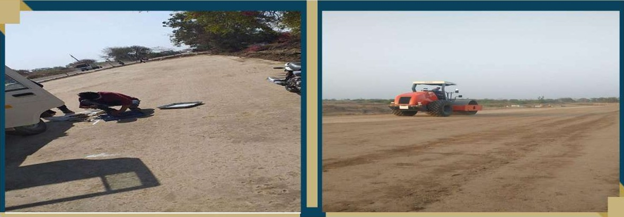

  - Rehabilitation and Upgradation of Razad-Vita NH 166E fcom Km C4/614 To Rm.182/117 with paved shoulders. Cost
Of Wock: Rs. 4.50 To 5.00 Czoces
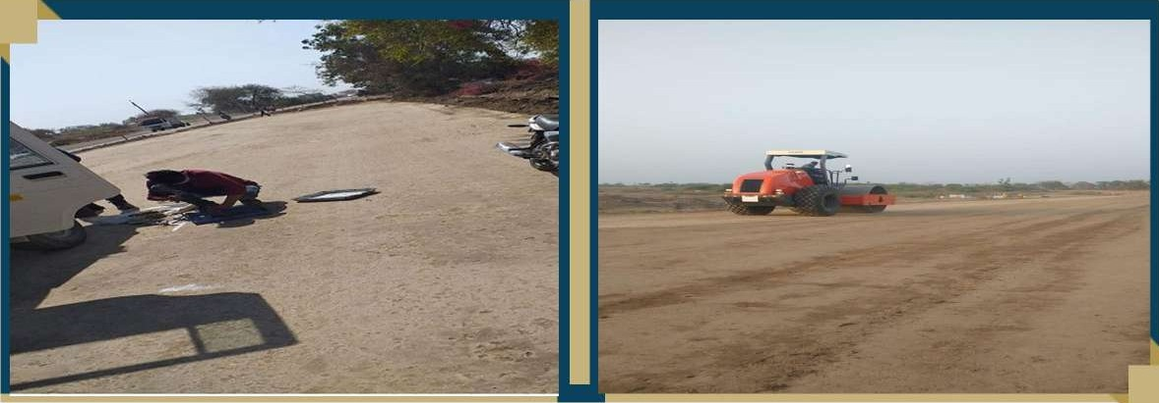


Date: 20'^{h}JULY 2024

SR.MO. | 
1. | DUMPER | MH-15-JC-5145
3. | DUMPER | MH-15-JC-5154
 | DUMPER | MH-15-JC-5190
7. | SOIL COMPACTOR | CASE
q. | HYDRALIC EXCAVATOR | LIUGONG
11. | GRADER | MH-15-HC-6306
13. | TRANSIT MIXER | MH-06-AQ-7106
15. | JCB | MH15DL1210

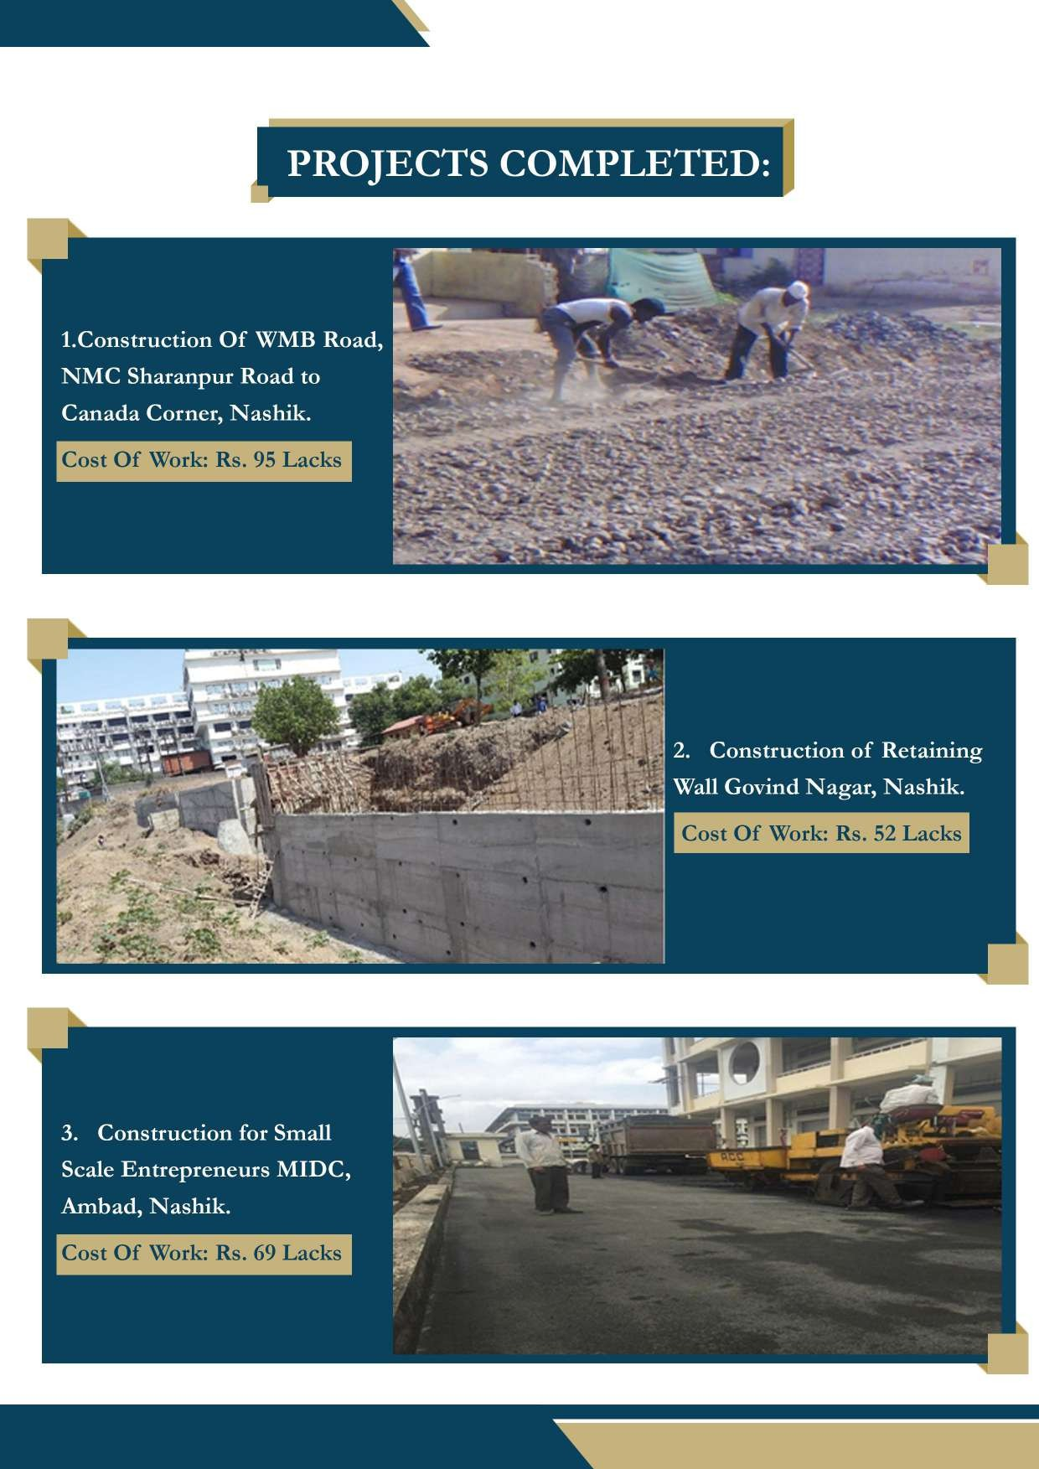

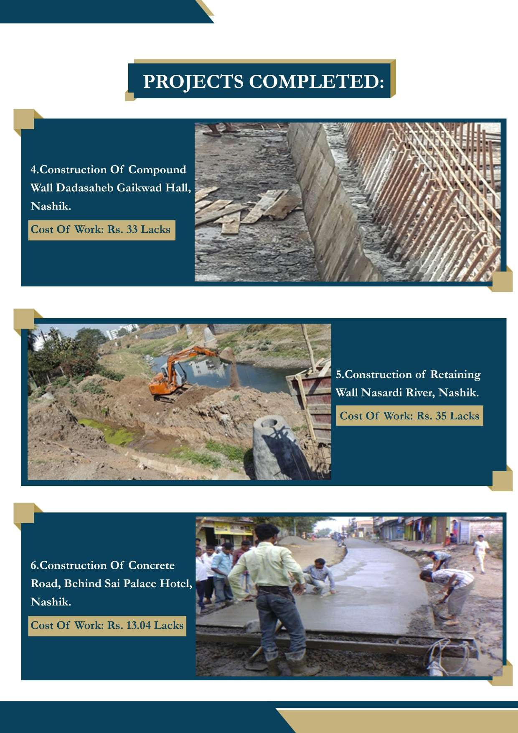

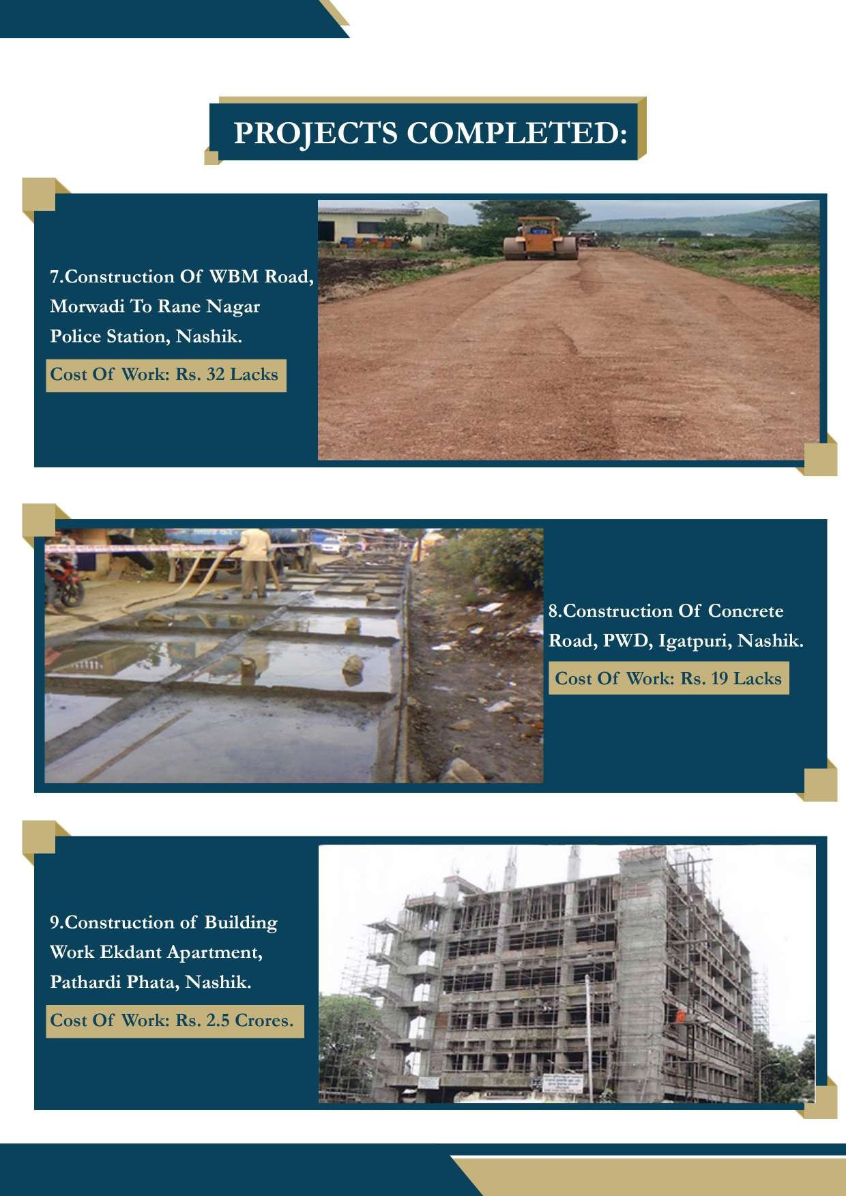

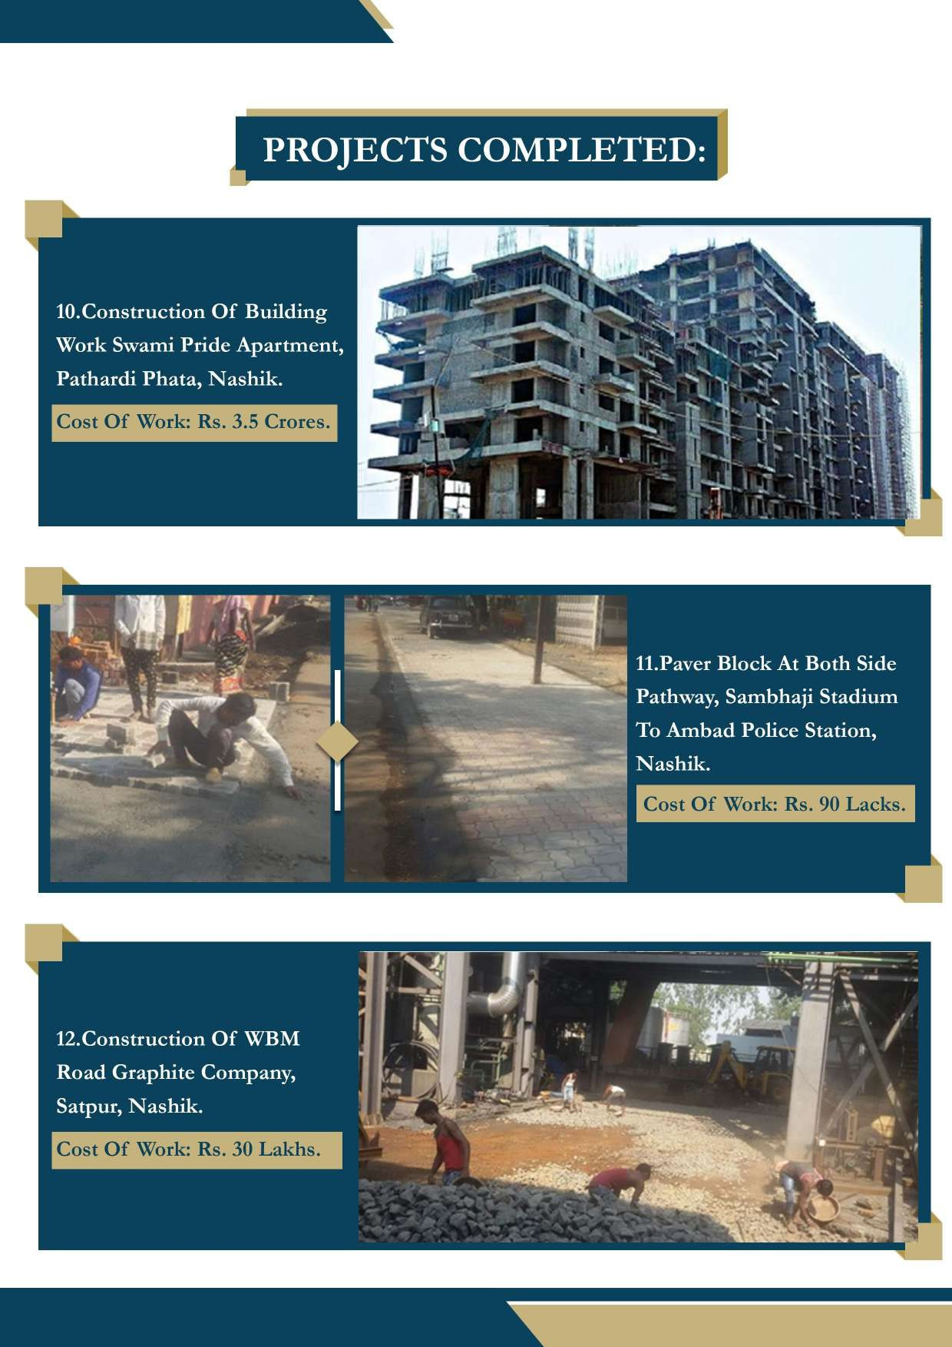



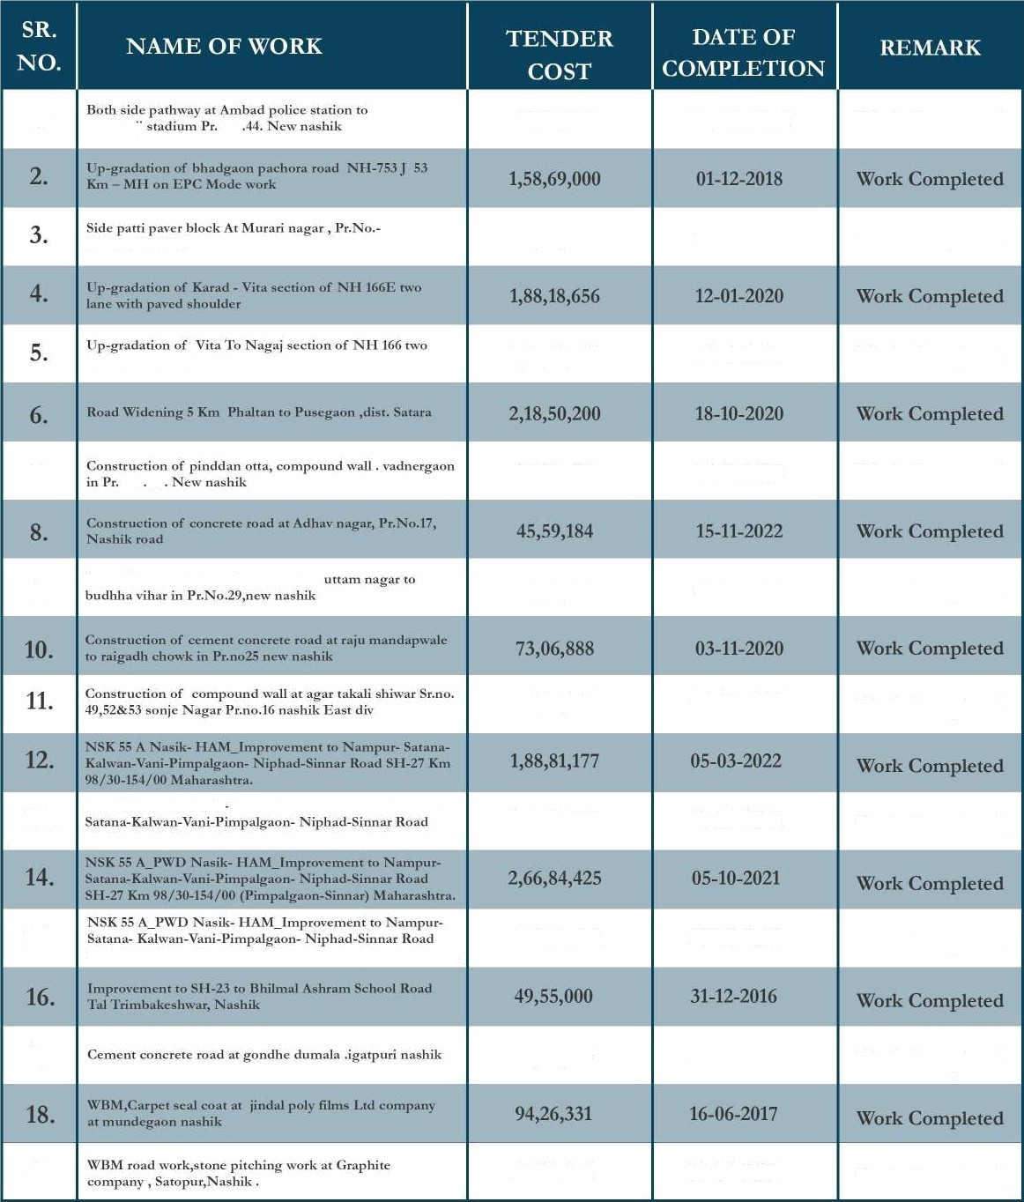

No 96,86,000
07/03/2018
Wozk Completed

28 New Nashik
16,40,000

1,69,01,707
30-05-2019 Work Completed

23-5-2020 Work Completed

7. No 22
39,72,519
15—11—2022
Wozk Completed

P ver Block work At shubham part to
9.
59,51,545
28-04-2021 Work Completed

74,56,056
25—02-2021
Work Completed

is

15.

17.

19.
NSK 55 A PID Naoik HAM_Improvmnent in I Iampur-
SH-27 km 98/311-154/00 (Pimpalgaon-Sinnar) Maharashtra.

SH-27 Km 98/30-154/00 (Pimpalgaon-Sinnar) Maharashaa.
2,43,31,754

1,71,85,505

86,77,185

56,98,214
10-01-2022

20-03-2021

15-12-2015

23-04-2018

Work Completed

Work Completed

Work Completed

Work Completed

